**Project Design Phase-I**

**Solution Architecture**

|  |  |
| --- | --- |
| Date | 8 October 2022 |
| Team ID | PNT2022TMID17917 |
| Project Name | Analytics for Hospitals' Health-Care Data   |  | | --- | |  | |  | |
| Maximum Marks | 4 Marks |

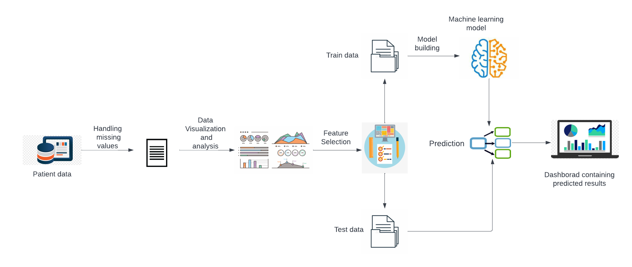**Solution Architecture :**